# Operational Concept Description (OCD)

**NICE**

**TEAM 7**

Deborah Baker – Assistant PM, QFP (Team & Web Req), IIV & V, Team Website Admin

Antonis Papantoniou – Prototyper, Project Manager

Runxuan Wei – Prototyper, Life Cycle Planner

Weijiang Dang – Developer, Operational Concept Engineer

King Lun Au – Developer, Life Cycle Planner

Dhananjay Nakrani – Prototyper, Operational Concept Engineer, Team Website Admin

**October 15, 2015**

# Table of Contents

Operational Concept Description (OCD) i

Table of Contents ii

Table of Tables 1

Table of Figures 2

Introduction 3

1.1 Purpose of the OCD 3

1.2 Status of the OCD 3

2. Shared Vision 4

2.1 Benefits Chain 5

2.2 System Capability Description 6

2.3 System Boundary and Environment 7

3. System Transformation 8

3.1 System Objectives, Constraints and Priorities 8

3.2 Proposed New Operational Concept 9

3.3 Organizational and Operational Implications 13

# Table of Tables

Table 1: The Program Model 4

Table 2: Relation to Current System 8

# Table of Figures

Figure : Benefits Chain Diagram of NICE Ecommerce Website

Figure 2: System Boundary and Environment Diagram

Figure 3: Element Relationship Diagram of NICE Vendor Case

Figure 4: Element relationship diagram of NICE Customer case

Figure 5: Business Workflow vendor application

Figure 6: Business Workflow search & purchase

Figure 7: Business Workflow for newsletter flow

# Introduction

#### Purpose of the OCD

This document provides, in detail, the shared visions and goals of the stakeholders of the Eternal Wellness. The success-critical stakeholders of the project are Lyn Yamore owner of Eternal Wellness, James Davis, the NICE Project client, we Team 7 as the development team and finally the vendors and buyers who will populate the website.

#### Status of the OCD

The status of the OCD is currently at the prototyping version still comparing different COT working with different prototypes to determine the pros and cons between them. Future versions will be based on one of those prototypes to incorporate MMF set by the client.

### Shared Vision

|  |  |  |  |
| --- | --- | --- | --- |
| **Assumptions**   * People are interested in buying the clients’ products online * There is a market for these products – people desire health-related products * Vendors are interested in selling | | | |
| **Stakeholders** | **Initiatives** | **Value Propositions** | **Beneficiaries** |
| * Developers * Clients * Maintainers * Customers/Consumers * Vendors/Suppliers | * Design & develop the new system * Maintain the system * Training, documentation and tutorials * Marketing,   Host a blog with information to educate consumers   * Vendors populate website with products * Vendor Management, Payouts * Website Maintenance | * Connect suppliers with consumers * Educate consumers * Provide economic development * Empower entrepreneurs * Provide a platform to purchase herbal & health related products | * Consumers * Vendors/Suppliers |
| **Cost** (Cost factors)   * Development costs * Maintenance costs * Web server hosting, domain name | | **Benefits** (Key performance indicators – KPIs)   * Increase in net income generated from suppliers sales * Increase in the number of suppliers, customers and subscribers | |

Table : The Program Model

**Legend:**

Initiatives that need to be undertaken to help beneficiaries **derive value** from the expected benefits/value propositions

Initiatives that need to be undertaken to help **deliver value** to the beneficiaries (i.e. “how” will the benefits reach the beneficiaries?)

#### Benefits Chain

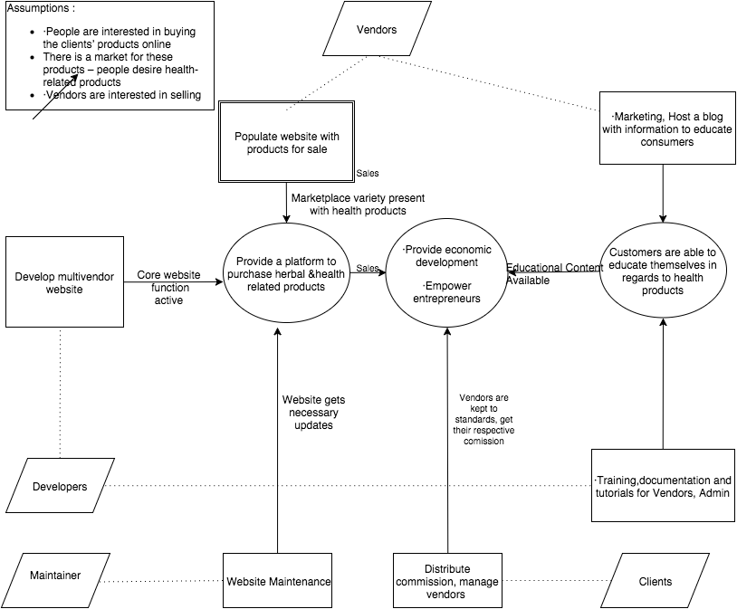

Figure : Benefits Chain Diagram of NICE Ecommerce Website

#### System Capability Description

With the NICE Ecommerce platform local health product vendors that usually sell within their vicinities and in small quantities will be able to take their business to the next level by listing their products on nice.com. Additionally their products will gain a much bigger exposure and also with the use of the platforms blog functionality they will be able to promote and market their products much cheaper and to a bigger and more targeted audience than before. Similarly customers using this website will have a bigger variety of products to choose from and they don’t have to visit the stores in person or through each vendors personal webpage. By having this bigger variety they will be able to choose the products that are tailored to their needs.

#### System Boundary and Environment

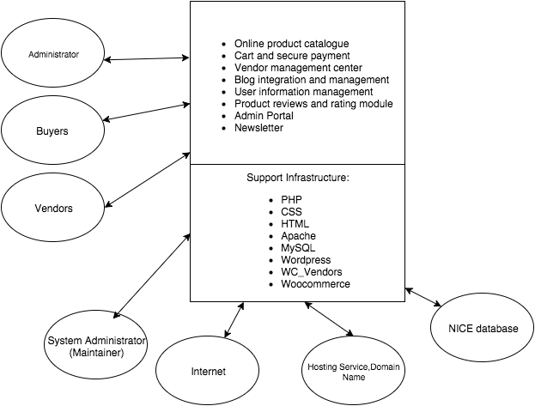

Figure 2: System Boundary and Environment Diagram

### System Transformation

There is no current system operating at the client organization to our knowledge, this is going to be the first platform for NICE commerce

#### System Objectives, Constraints and Priorities

##### Capability Goals

Table 1: Capability Goals

|  |  |
| --- | --- |
| **Capability Goals** | **Priority Level** |
| OC-1 The System has search function and product listing | Must have |
| OC-2 Multiple vendors can publish products. | Must have |
| OC-3 Customers can purchase products | Must have |
| OC-4 Vendors can add edit their personal blogs | Moderate |

##### Organizational Goals

**OG-1:** Create global healthcare market by creating an online multivendor platform

**OG-2**: Promote local producers and vendors through blogging and using the Internet

**OG-3:** Allow consumers to have easier access to locally produced health products and educate themselves about their purpose and their variety.

##### Constraints

**CO-1: Low Monetary Budget:** The total project should not exceed the budget set by the client.

##### Relation to Current System

Table : Relation to Current System

|  |  |  |
| --- | --- | --- |
| **Capabilities** | **Current System** | **New System** |
| Roles and Responsibilities | N/A | Create new admin position |
| User Interactions | N/A | Users will interact through online platform |
| Infrastructure | N/A | Employ web service infrastructure |
| Stakeholder Essentials and Amenities | N/A | Vendors and Users will have new means of interaction. |
| Future Capabilities | N/A | Scalability to incorporate a greater amount of users/vendors |

#### Proposed New Operational Concept

##### Element Relationship Diagram

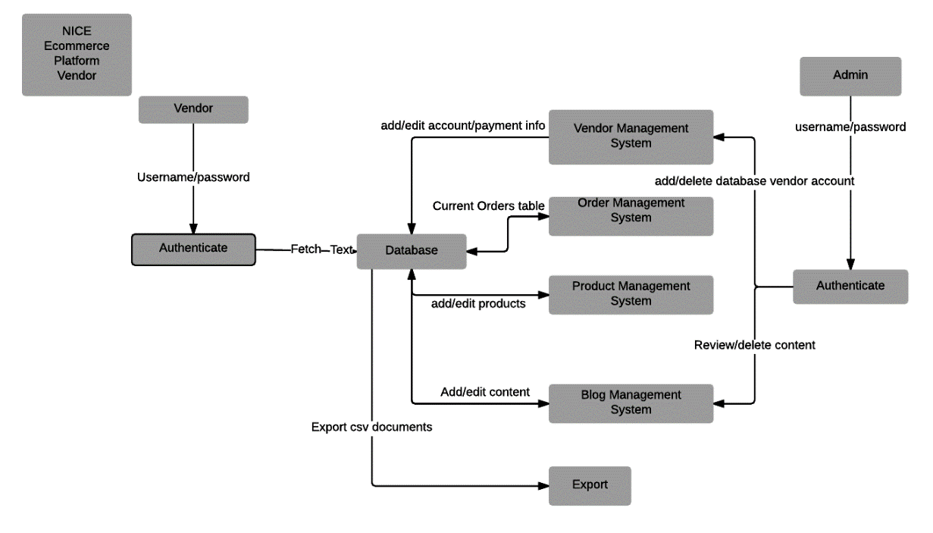

Figure 3: Element Relationship Diagram of NICE Vendor Case

On Figure 3, the element relationship diagram shows the relationships between the vendor, databases and admin and the main flow of information in the planned platform. From the elements portrayed a lot are provided from the COTs and some need to be developed.

Wordpress, Woocommerce, and WC_Vendors provide the vendor management system, authentication and multivendor aspect. One challenge was incorporating blogs for each vendor and having the process automated along with the blog management system.

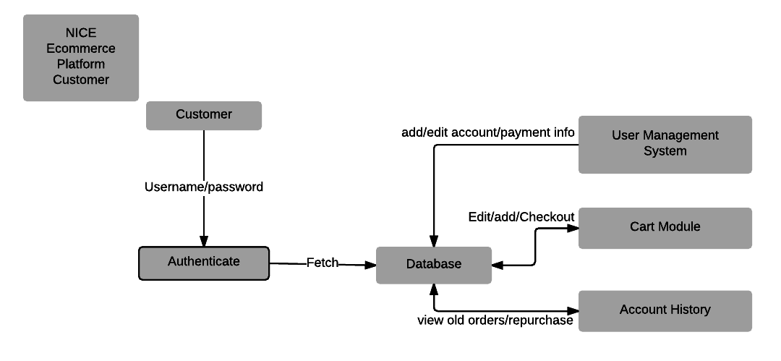

Figure 4: Element relationship diagram of NICE Customer case

On Figure 4, the COTs provide most of the elements. Woocommerce provides most of the functionality necessary in terms of cart module and user management system. Most of the developmental work in terms of cart module went into testing and connecting the payment portal with PayPal to remove any security concerns regarding credit card safety.

##### Business Workflows

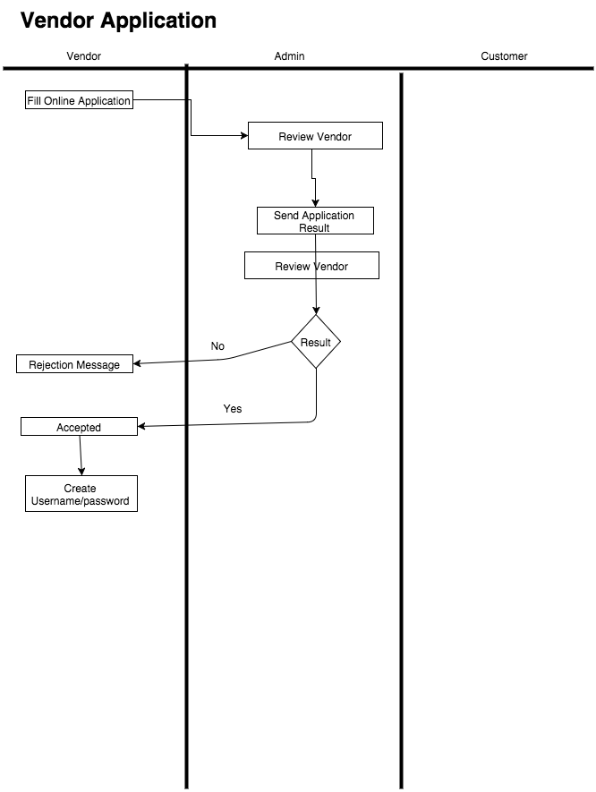

Figure 5: Business workflow for Vendor Application

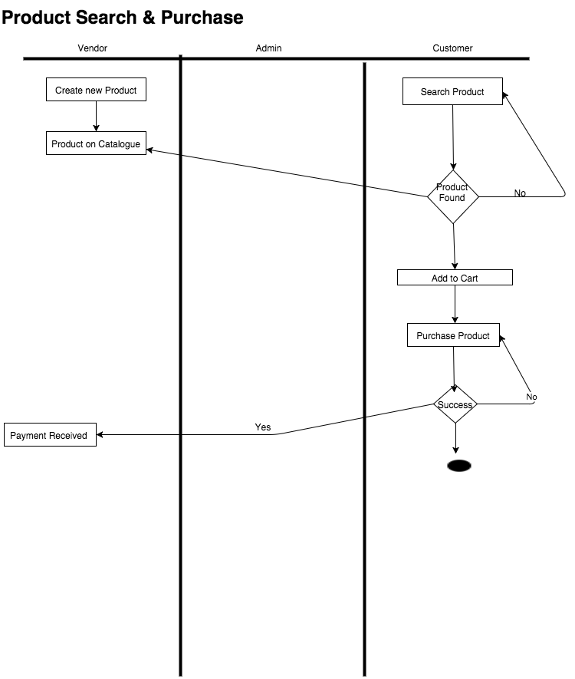

Figure 6: Business workflow for product search & purchase

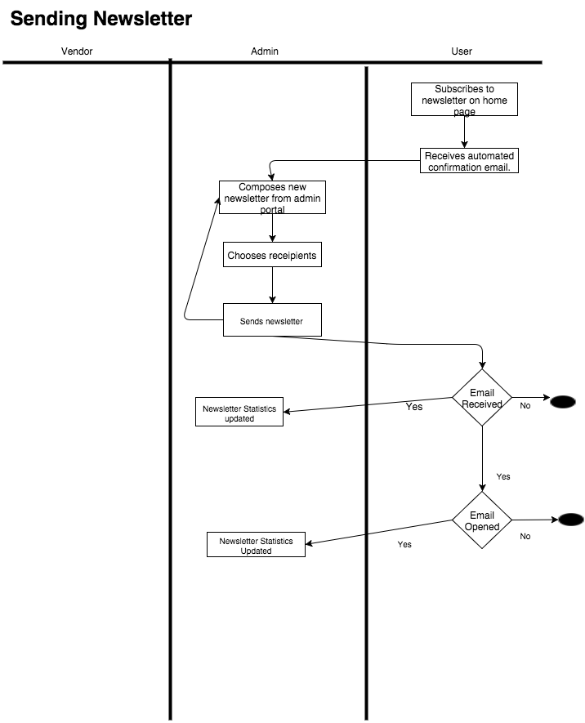

Figure 7: Business workflow for newsletter flow

#### Organizational and Operational Implications

##### Organizational Transformations

The company will need to enlist an active website administrator who will monitor blog posts, approve vendors and manage accounts. The administrator will also be responsible to respond to customer related issues such as non-delivered product etc. Additionally the website administrator will be responsible for updating the home page by changing for example the featured vendors or the featured products. Finally he will be responsible for sending out regular newsletters to the subscribers.

A website maintainer should also be enlisted to perform basic maintenance, such as plugin updates, website backup and finally website migration if necessary. This maintainer should have some understanding of unix, php and also working with hosting services like GoDaddy.

##### Operational Transformations

As this is a new system, no operational transformations will be made. Instead the whole workflow and business model of the company must be set up from ground up and change the model of operations to respond to this new venture.